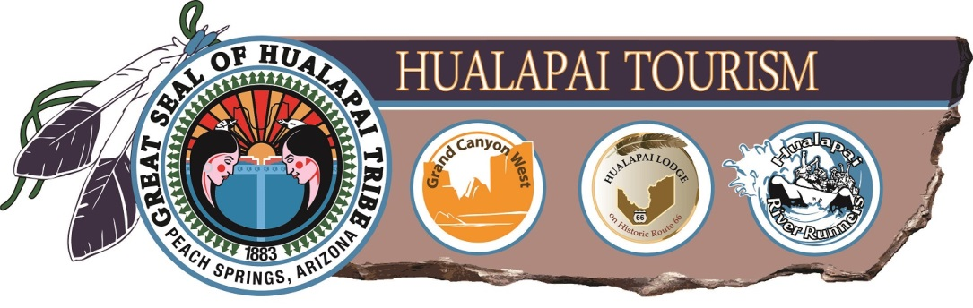

HWAL’BAY BA:J Enterprises, Inc.
Board of Directors
Vacancy Position Announcement
Posted August 5th, 2016

The Hualapai Tribe is seeking a qualified candidate for the HWAL’BAY BA:J Enterprises, Inc. (“HBBE”) and Grand Canyon Resort Corporation Board of Directors. One position is vacant.

HBBE, doing business as Grand Canyon Resort Corporation, operates Grand Canyon West, Grand Canyon Skywalk, Hualapai Lodge, Hualapai River Runners, and related businesses. Grand Canyon West operates the world famous Skywalk attraction. Successful applicants will be interviewed and selected by the Hualapai Tribal Council.

Qualifications – knowledge of hospitality and tourism operations, finance, law, marketing and/or business development. The chosen candidate will be expected to attend monthly Board meetings in Peach Springs, AZ, as well as perform committee work. Board members are compensated for reasonable expenses to attend monthly meetings and are paid a nominal board fee.

Please send a letter of interest and resume to:

Grand Canyon Resort Corporation
Attn: Human Resources Director
P.O. Box 359
Peach Springs, AZ 86434
Fax: 928-769-2410
Geoff.Miller@grandcanyonresort.com

All applicants will be required to undergo a thorough background investigation.

All applications must be received by September 5th, 2016

